Step 2 – Bumper

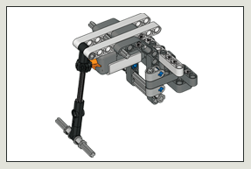

Can you build the robot so that it reacts to its environment? You’ll need to build a bumper using the Touch Sensor.

BUILDING GUIDE:

- / 6

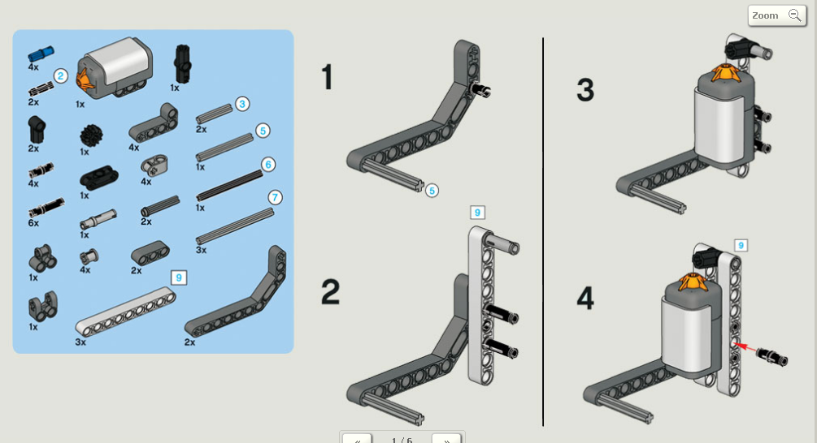

- / 6
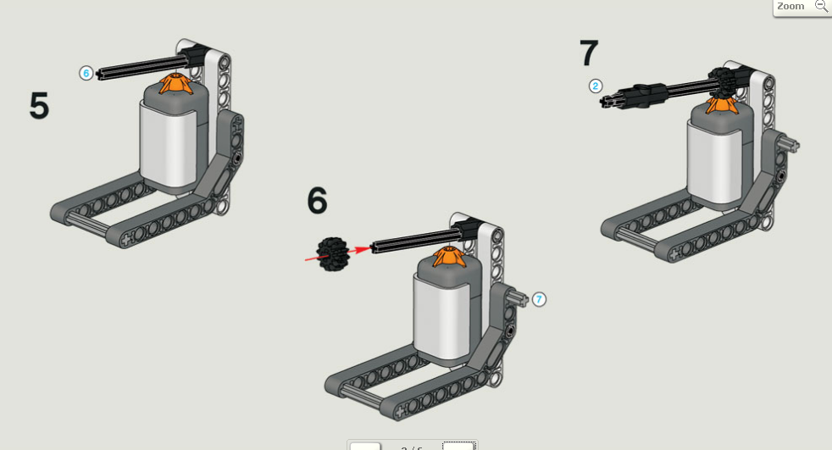

- / 6
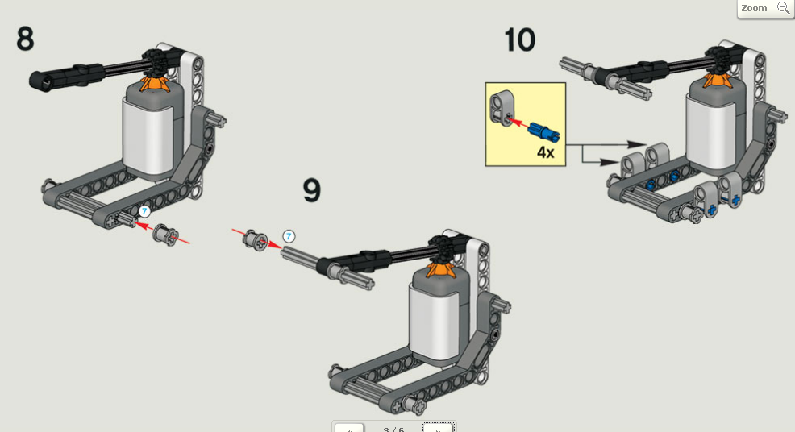

- / 6
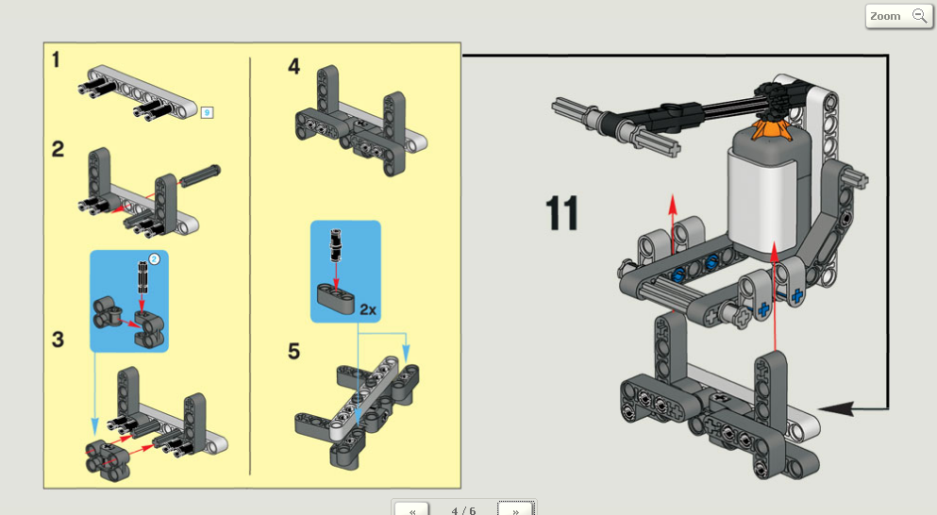

- / 6
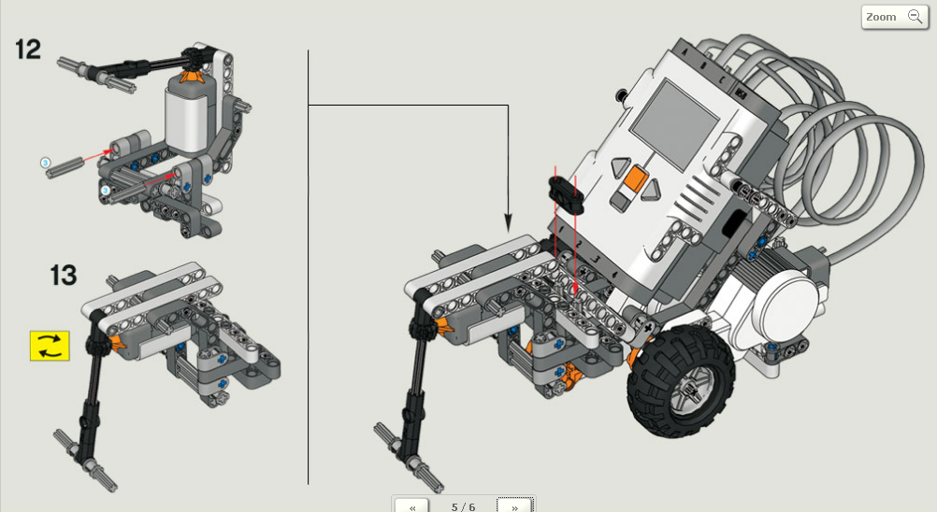

- / 6
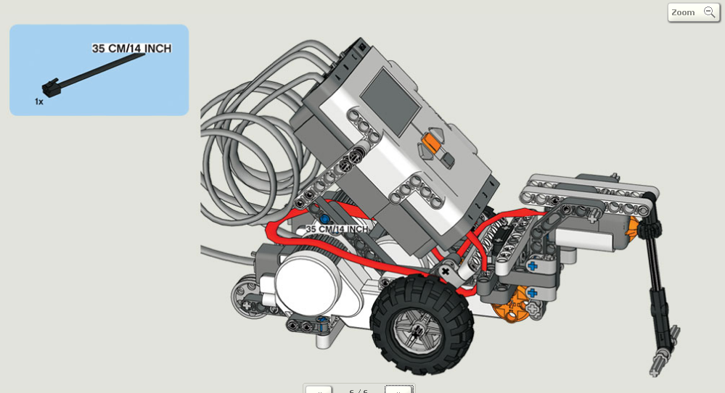

PROGRAMMING GUIDE:
Can you program the robot to go forwards until it bumps into the ball, then reverse back to the starting point at a faster speed?
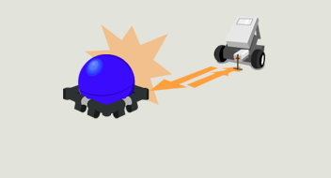
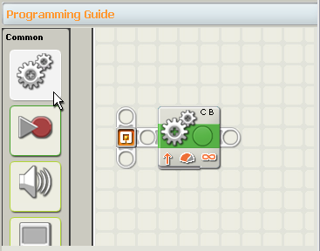

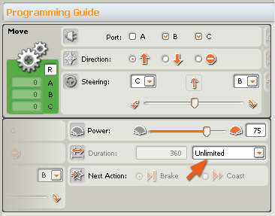
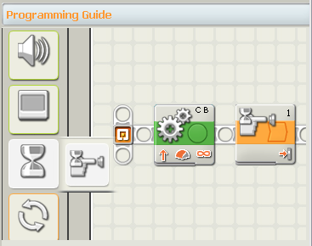
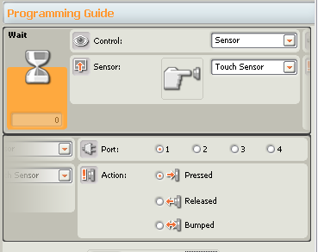

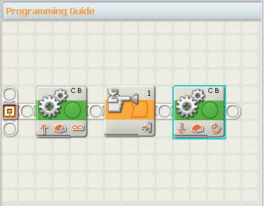
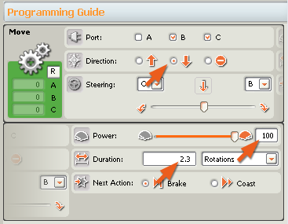

TEST GUIDE:

Download your program. Place your robot and the ball on the test pad and run the program.
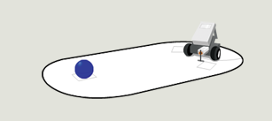
Your robot should go forwards until it bumps into the ball.
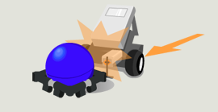
Your robot should then reverse back to the starting point at a faster speed.
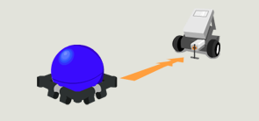

See if the robot:
1. Automatically goes in reverse when it touches the ball.
— If it doesn’t reverse, make sure to check the direction of the Move Blocks.
— Make sure the Touch Sensor is connected with a black wire to port 1.
2. Stops when you want it to stop.
— If it doesn’t stop at the starting point, try adjusting the distance on the Move Block.

