Step 3 – The Grabber

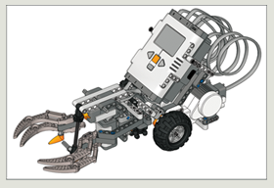

Can you build the robot so that it can grab an object and keep hold of it? You’ll need to build a claw onto the driving base.

BUILDING GUIDE:

1 / 4
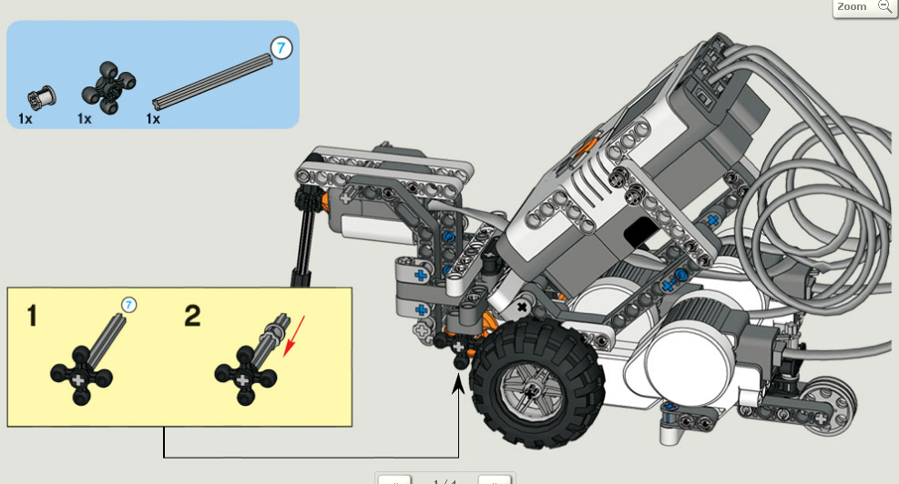
2 / 4
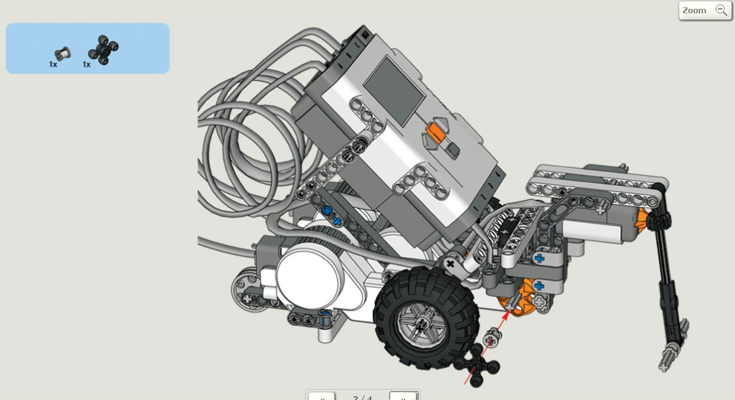

3 / 4
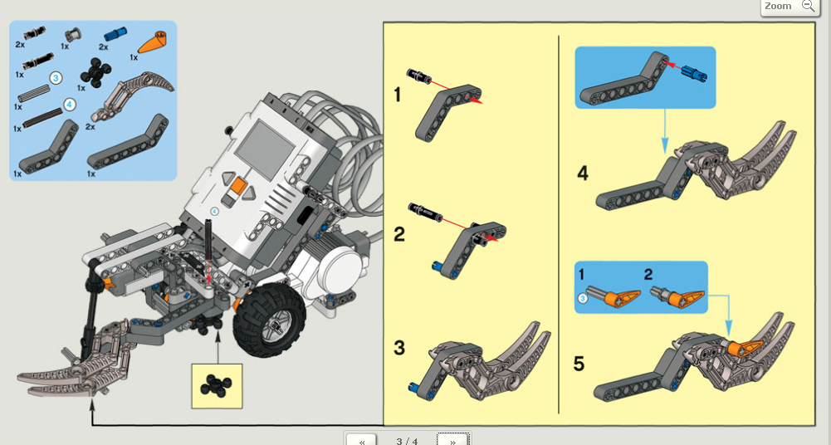

4 / 4
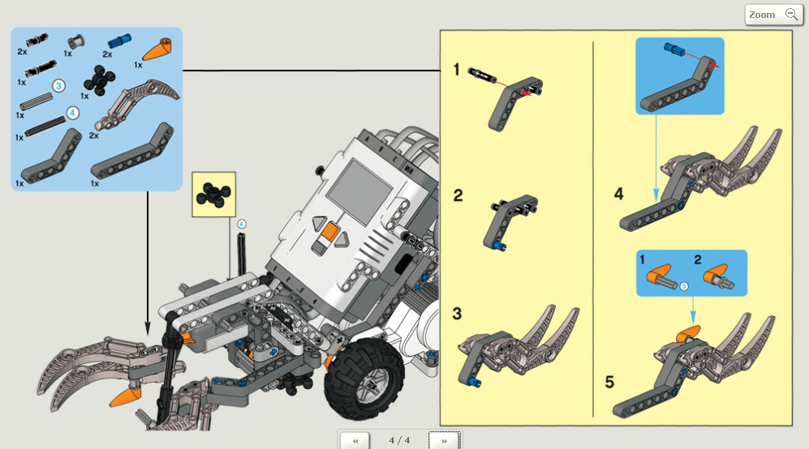

PROGRAMMING GUIDE:

Can you program the robot to go forwards until the Touch Sensor bumps into the ball, then stop, grab the ball and reverse back to the starting point at a faster speed?
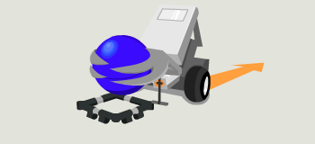
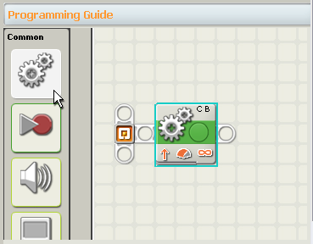
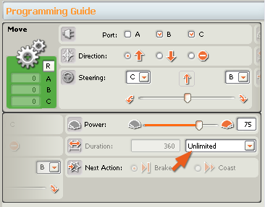
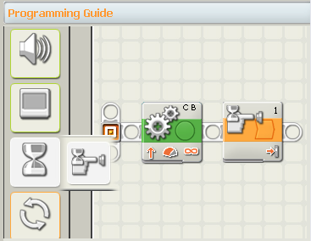

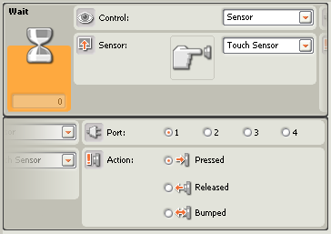

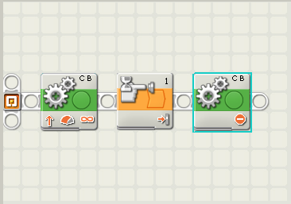

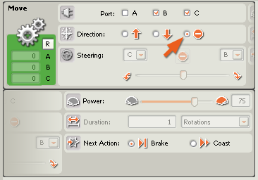

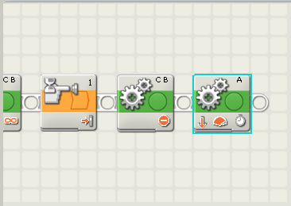

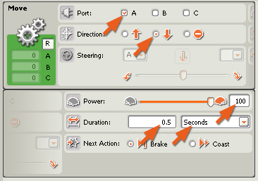

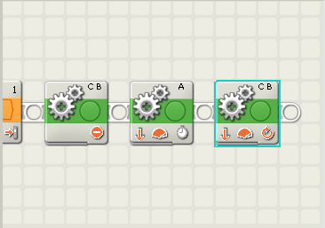

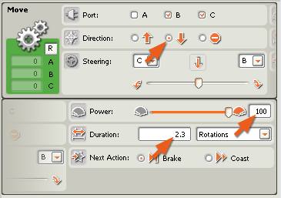

TEST GUIDE:

Download your program. Place your robot, with the grabber fully open, and the ball on the test pad, then run the program.

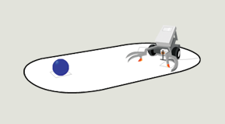

Your robot should go forwards until the Touch Sensor bumps into the ball, then stop!

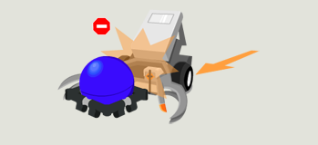

Your robot should grab the ball.

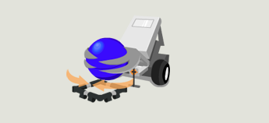
Your robot should reverse back to the starting point at a faster speed.
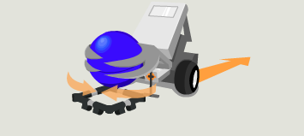

See if the robot:
1. Stops when it touches the ball.
— Make sure the Wait Block is configured to Touch Sensor being pressed.
2. Picks-up the ball.
— If it doesn’t, then try changing the amount of seconds on the Move Block.
3. Reverses back to you.
— Try changing the direction on the Move Block.

