The Game

Overview:

The FLL camp game will consist in a race type format. Robots will race against each other via a time trial. The track will not be in a straight line but will change direction at 90° angles. Random black tape will be placed in locations for the robot to go around using their light sensor.

Dimensions:

The Robot must not exceed 8 inches wide, 8 inches long, and 10 inches height. The track will be 30 inches wide. And will be in a box shape with a 10 foot long and 6 foot wide. The first side will consist of triangle obstacles, the second will consist of circles and the third will consist of squares. The last side will be a straight away with black tape on each side. See Figure 1:

Figure 1:


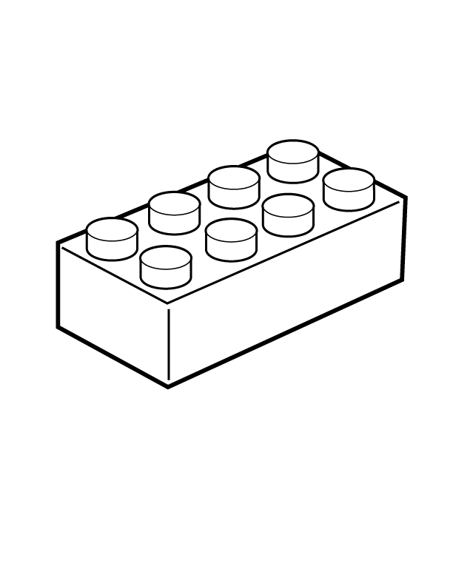
Finish

Start
30 in
6 ft
10 ft

