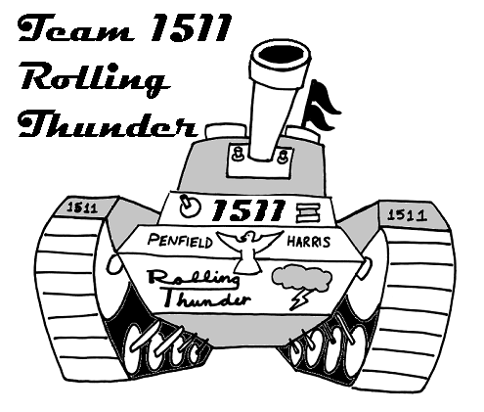
Dear Parent/Guardian,
Kimberly O’Toole
1680 University Ave
Rochester, NY 14610
585-242-3353
kotoole@harris.com November 3, 2004
Your student has chosen to be a part of the FIRST Robotics Team at the high school. We would like to take a minute to give you a little background on the program, and let you know what to expect in the upcoming months.

FIRST stands for “For Inspiration and Recognition of Science and Technology,” and was the brainchild of Dean Kamen, inventor of the Segway, the Portable Dialysis Machine, and the Wheelchair that climbs stairs and stands upright (among many other inventions). His idea was to give high school students the opportunity to be as inspired about science and technology as they were about sports. He wanted them to have the opportunity to look up to engineers and scientists the same way that they looked up to baseball and basketball players.

FIRST is based around a 6 week design and build session, in which teams are given a kit of parts and a game like task to perform. This year it starts on January 8th. At the end of the six weeks, all work stops and the robot must be shipped. Once the robot is shipped teams can compete in Regional competitions all over the United States. Each Regional competition presents the opportunity to qualify for nationals through winning awards and/or the event. The preseason time is used for learning the necessary skills, teambuilding and fundraising.

Harris Corporation is proud to be sponsoring the team at Penfield High School, and has over 20 engineers & staff volunteering mentoring support for the program. Harris will be paying for registration and other team fees. Students are required to raise the money for their travel through a variety of fundraisers including car washes, patron drives, dances, etc. All fees outside of student travel will be covered by Harris.

Our team has elected to participate in three Regional competitions this year, in the hopes of qualifying for the National Competition in Atlanta, Georgia. We are currently registered for Regionals in Rochester, NY and Cleveland, OH. The third Regional registration has not opened yet, but we hope to attend Pittsburg, PA or Hartford, CT.

We have a lot more information to provide you, and would be happy to answer any questions. We will be holding a Parents Info Session/Meeting on Thursday November 18th at the High School in the cafeteria. If you cannot attend this meeting, please contact me at the above email or phone numbers and I can forward the information on to you. We will be looking for parental assistance with food, fundraising and travel arrangements for the team, as well as any other expertise that can be offered.

All of this said, I can attest to how incredible this program will be for your student. I joined the FIRST program at a high school in CT in 1996 as a sophomore. Through FIRST, I not only learned about engineering, but teamwork, presentation, organization and many other valuable skills. The engineers were not only my mentors, but became friends and great contacts. FIRST was an incredible asset in getting me into Clarkson University, where I started another FIRST team in 1998, as well as getting me my job at Harris Corporation here in Rochester. Colleges around the U.S. now provide millions of dollars in scholarships to high school students involved in the program, and as more and more corporations start FIRST teams, they know the type of students it produces.

We look forward to meeting you at the parents meeting on Thursday November 18th, 6pm in the High School cafeteria. If you cannot make it but would like more information, feel free to contact me!

Sincerely,

Kim O’Toole

