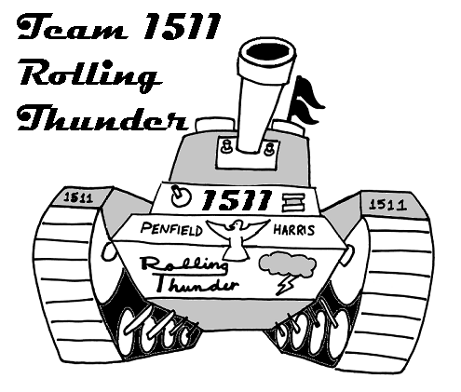
Team 1511 Rolling Thunder
Trip Sign-up Form

Please indicate on the form on the next page, which trips you will attend. This form is due in NO LATER than January 27th. Deposits will be accepted until February 1st.
This is the OFFICIAL indication that you will attend the trips. Deposits are NON-Refundable, and students will be responsible for paying any fees associated with canceling their reservations. (Harris has decided to pay the balance of the regional trips, with the caveat that if the team makes it to the national competition, there will be NO Harris funding remaining. The team will be responsible for paying/fundraising the entire amount if it is decided to go to the National Competition.)

Recommended Spending $$: This is just an estimate of what the student would need for spending money for meals, food and miscellaneous items per day. NOTE: No food or drink will be allowed to be brought into the venues, so your student must bring money in order to eat/drink during the day.

Trip Details

Rochester Regional March 3-5
Deposit $Free*
Thursday March 3: Drive Team & Key Students (vehicle transportation)
Friday March 4: Entire Team (vehicle* transportation)
Saturday March 5: Entire Team (vehicle* transportation)
Recommended Spending $$: $15/day (lunches & snacks)

Cleveland Regional March 24-26
Deposit Due $75
Wednesday (3pm): Drive Team & Key Students Travel (vehicle transportation)
Thursday: Drive Team & Key Students at Cleveland (vehicle transportation)
Thursday (noon): Remaining Team leaves from Penfield (bus transportation)
Friday: Entire Team (bus transportation)
Saturday: Entire Team (bus transportation)
Saturday (~11pm*): Team Returns to Penfield (bus transportation)
Recommended Spending $$: $20-30/day (meals, snacks & souvenirs)

Toronto Regional March 31-April 2
Deposit Due $75
Wednesday (3pm): Drive Team & Key Students Travel (vehicle transportation)
Thursday: Drive Team & Key Students at Cleveland (vehicle transportation)
Thursday (noon): Remaining Team leaves from Penfield (bus transportation)
Friday: Entire Team (bus transportation)
Saturday: Entire Team (bus transportation)
Saturday (~10pm): Team Returns to Penfield (bus transportation)
Recommended Spending $$: $20-30/day (meals, snacks & souvenirs)

* Denotes change since last form.
Student Sign Up Form

I understand that by signing this form I am indicating which trips I will attend. I also understand that I will have to provide deposit for the trips I want to attend by February 1st. I understand that I am responsible for paying for any cancellation fees if I do not attend the indicated trips. I will also be responsible for my own spending money.

Student’s Name: ______________________________

I will attend the following events:

 Rochester Regional
March 3-5

 Cleveland Regional
March 24-26
 $75 Deposit included  $75 Deposit will be paid by Feb 1st

 Toronto Regional
March 31-April 2
 $75 Deposit included  $75 Deposit will be paid by Feb 1st

Student’s Signature: ________________________________

Student’s Name: ___________________________________

I give my student permission to travel either by bus or with any designated chaperone or Harris mentor as needed.

Parent/Guardian Signature: _________________________________

Parent/Guardian Name: ____________________________________

Note: Make Checks Payable to “Penfield High School Robotics Team”

